Dear partner,
We are happy to announce that we now welcome applications for the SDU International Summer School 2022
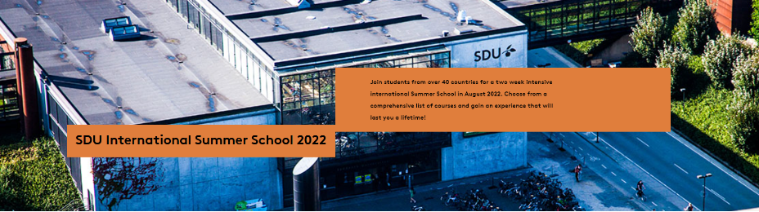
Get inspired by our International Summer School booklet and visit our website sdu.dk/summerschool for more on courses, accommodation, how to apply and much more!
SDU International Summer School quick facts
- Two weeks intensive courses
- 24 courses within engineering, science, computing, statistics and social sciences
- Dates: 6 – 20 August 2022
- Affordable accommodation arranged by SDU
- No tuition fees for students nominated through exchange agreements
Application and nomination
- Students can be nominated using relevant exchange agreements
- One exchange semester place equals four summer school places
- Nominations should be sent by email to summerschool@sdu.dk – please include the following information:
  - Name
  - E-mail
  - Study cycle
  - Programme at home institution
- The application deadline is 1 May 2022.
- Application is online

A few facts about SDU’s International Summer School
- Close to 500 students joined the summer school in 2021
- Courses are offered at our campuses in Odense and Sønderborg
- SDU ensures a rich offer of social activities, along with a wide variety of activities taking place in our campus cities

Got questions?
If you or your students have any questions, do not hesitate to contact us at summerschool@sdu.dk
We look forward to welcoming your students to SDU!

Venlig hilsen
Mette Østergaard Pedersen
AC-fuldmægtig
SDU International, Studieservice

T | 65 50 22 64
int-team2@sdu.dk

Syddansk Universitet
5230 Odense M
www.sdu.dk

